**Baseline Survey on WASH Governance**

Publication Type: WASH Baseline Survey

Report Topic: STUDY report of Baseline survey on Strengthening Municipal Wide WASH Governance for Social Change (SMWGSC) in 3 Municipalities of Siraha District, Nepal

Client: © SABAL Nepal/Welthungerhilfe

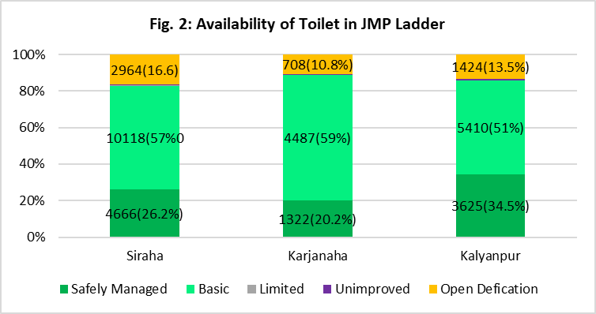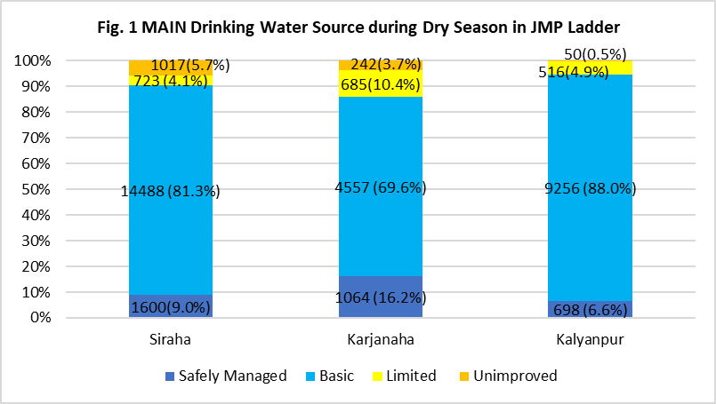The Constitution of Nepal recognizes access to safe drinking water and sanitation as a fundamental right (Article 35 (4); right to live in a healthy and clean environment; and provision of compensation for the victim of environmental pollution and degradation (Article 30). It has also provisioned WASH activities as the jurisdiction of local government (Schedule 8). Local Government Operation Act (LGOA) 2017 has mentioned the WASH as the roles and responsibilities of Local Government (Rules 11, (S)). As the international commitment, the Federal Government of Nepal has agreed to implement the Sustainable Development Goals (SDG) in which Water and Sanitation is defined as the goal 6 with 6 Target. As the implementing framework of SDG, Government of Nepal has formulated Nepal Water Supply, Sanitation and Hygiene Sector Development Plan (2016 – 2030) through Ministry of Water Supply and Sanitation. This sectoral development plan (SDP) is introduced as guiding framework for planning, implementing, coordinating and monitoring all activities in the WASH sector. Now, the Local Government can manage facilities to regulate the WASH service and can determine the tariff and tax against the services.

In this context, this base line survey has been carried out in 3 municipalities of Siraha district for Welthungerhilfe and SABAL Nepal to analyze the status of progress and existing situation of WASH in working clusters.

Survey shows that 3.7% of households are still using water from **Unimproved** source and nearly one out of seven households still admitted to open defecation (14.6%), households without toilet.

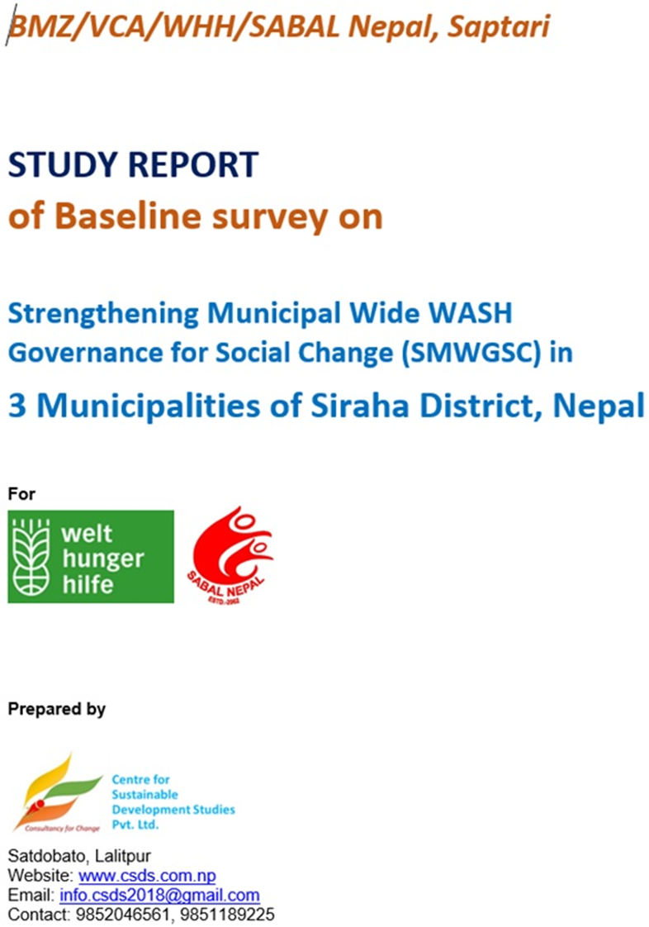

WASH Report PDF links